ASSIGNMENT

of

#### Augmented Reality and Virtual Reality Laboratory

**CS 435**

**Bachelor of Technology (CSE)**

By

Adit Desai ( 21124002 )

Fourth Year, Semester 7

*Course In-charge: Prof. Darshan Parmar*



Department of Computer Science and Engineering

School Engineering and Technology

Navrachana University, Vadodara

Spring

Objective: To create a basic VR game with a virtual environment in Unity that includes a ground plane, a skybox, environmental objects, lighting and simple VR interaction. The player should be able to grab and move the grabbable objects in the environment to score points.

**Task-1**

Setup your Unity Project and Configure the VR Environment

**Steps:**

* Create a new Unity project with the Universal Render Pipeline (Universal 3D) template.
* Navigate to Window -> Package Manager and install XR Interaction Toolkit from there. In the samples tab, import XR Device Simulator as well.
* Navigate to Edit -> Project Settings -> XR Plug-in Management and install XR Plugin Management. Once installed, check the OpenXR box.
* Under the XR Plugin Management tab, go to OpenXR and add the Oculus Touch Controller Profile and the Meta Quest Touch Pro Controller Profile.
* Now, right click in the Scene Hierarchy and add XR -> XR Origin (VR). This will add XR Interaction Manager and XR Origin (XR Rig) in the Scene Hierarchy.
* Set the Tracking Origin Mode to Floor in the XR Origin script.
* Go to Assets/Samples/XR Interaction Toolkit/2.5.4/XR Device Simulator and drag the XR Device Simulator prefab into the Scene Hierarchy.

**Screenshots:**

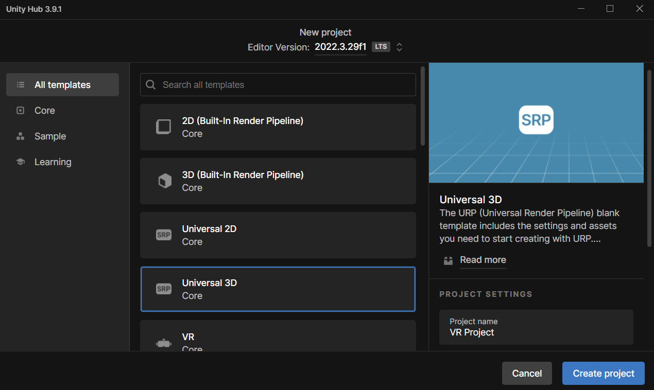

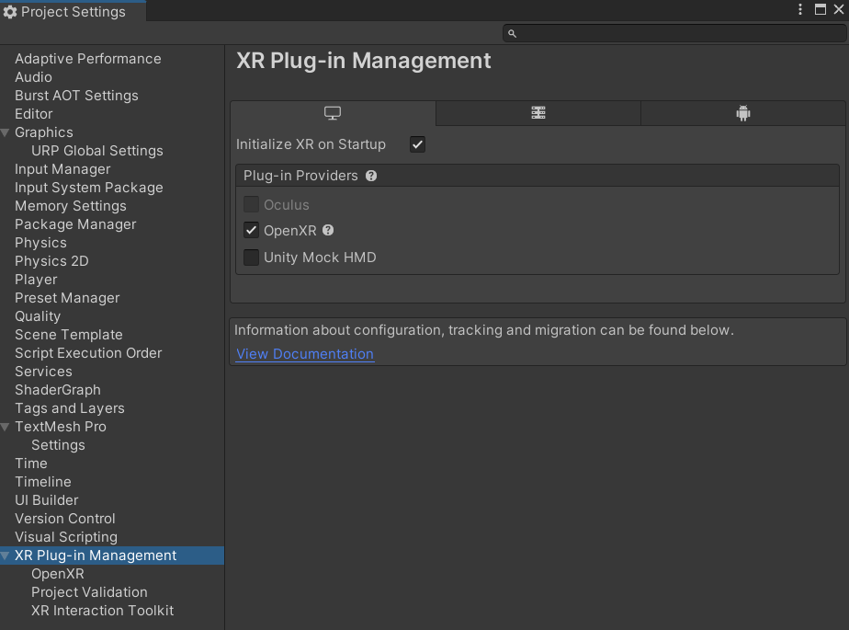

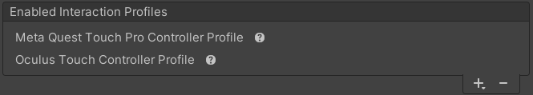

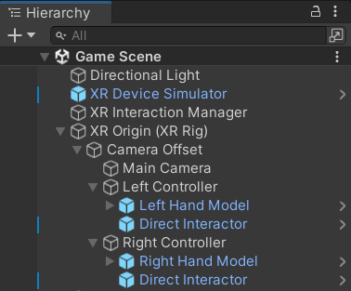

**Task-2**

Create the ground plane and add a skybox

**Steps:**

* Download and import the ADG_Textures, SkySeries Freebie and Forst assets from the asset store.
* Add the Unearthly Red skybox from SkySeries Freebie asset pack.
* Right click in the hierarchy and add 3D Object -> Terrain.
* Using the Paint Terrain -> Paint Texture tool, add and paint appropriate ground and road textures from the ADG_Textures pack.
* Using the Paint Terrain -> Raise or Lower Terrain, add elevation to the terrain.
* Using the Paint Trees option, add trees from the Forst asset pack and add paint trees in the terrain.

**Screenshots:**

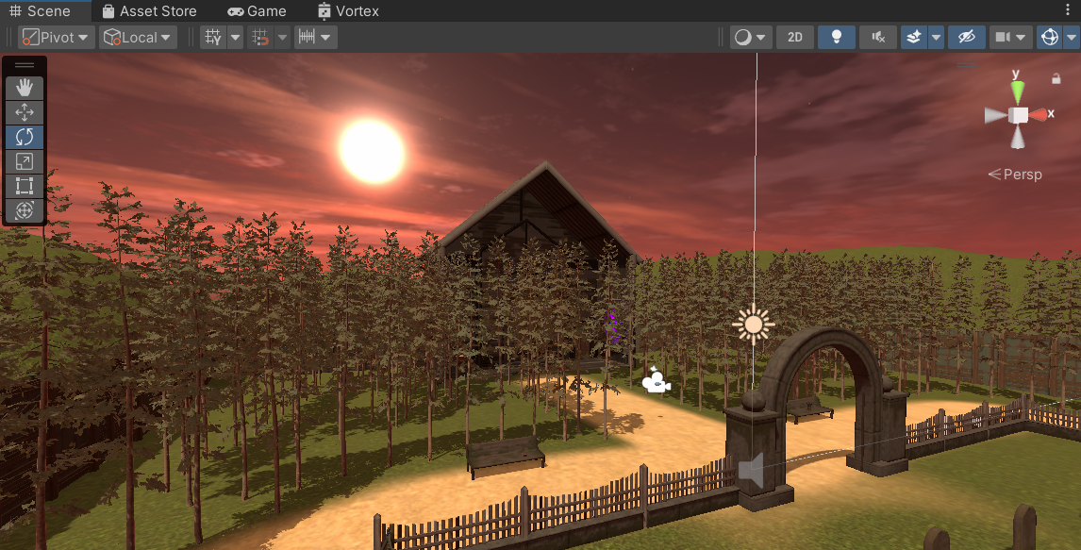

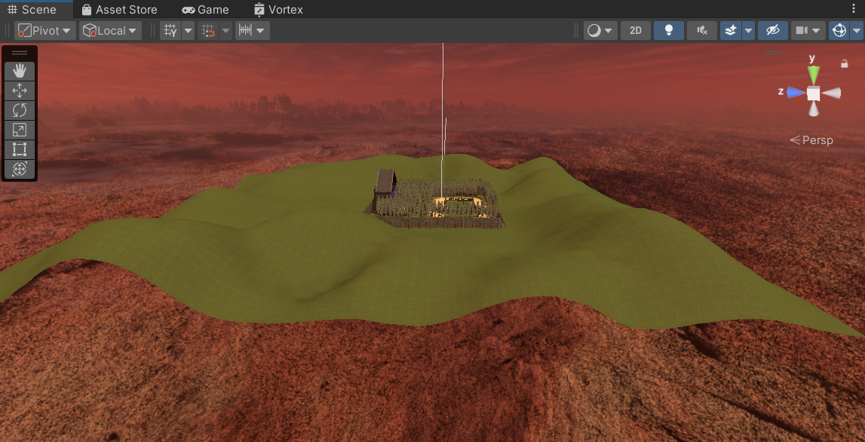

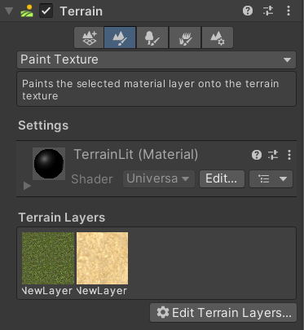

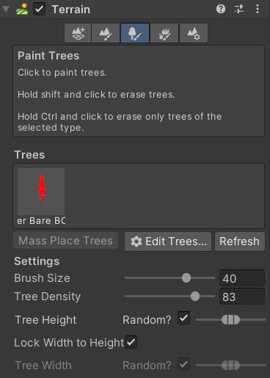

**Task-3**

Add environment objects

**Steps:**

* Download and import the Flooded Grounds asset pack from the asset store.
* Using the Flooded Grounds asset pack, create an environment using cabins, tables, props (vases, cups, etc), graves, fences, gates, etc.
* Place props, such as vases, lamps, flashlights, rust key, at random positions.
* Create a custom shader graph (right click -> Create -> Shader Graph -> URP -> Unlit Shader graph) and add it a quad (right click -> 3D object -> Quad) game object.
* Design the vortex portal effect as shown in the screenshots.

**Screenshots:  
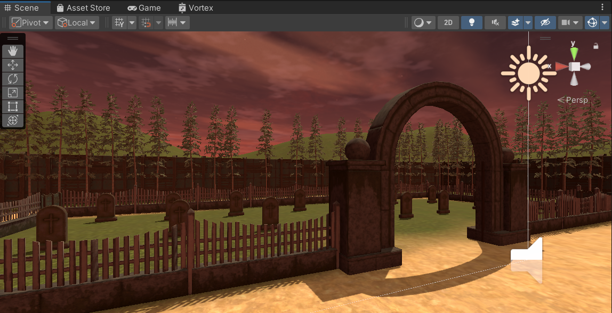**

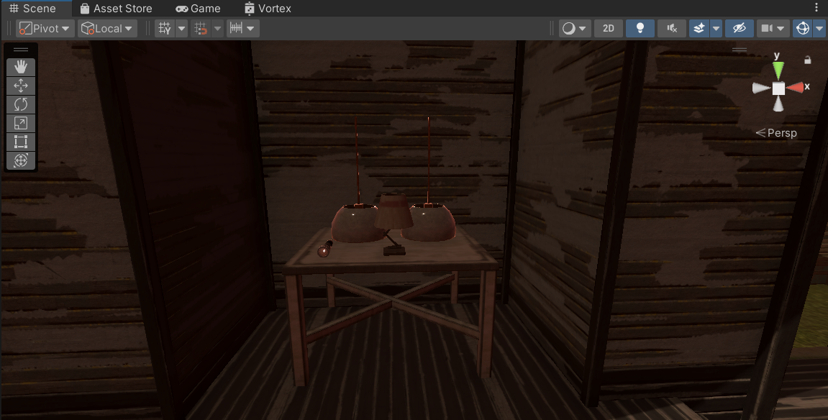

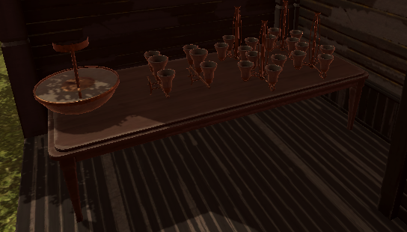

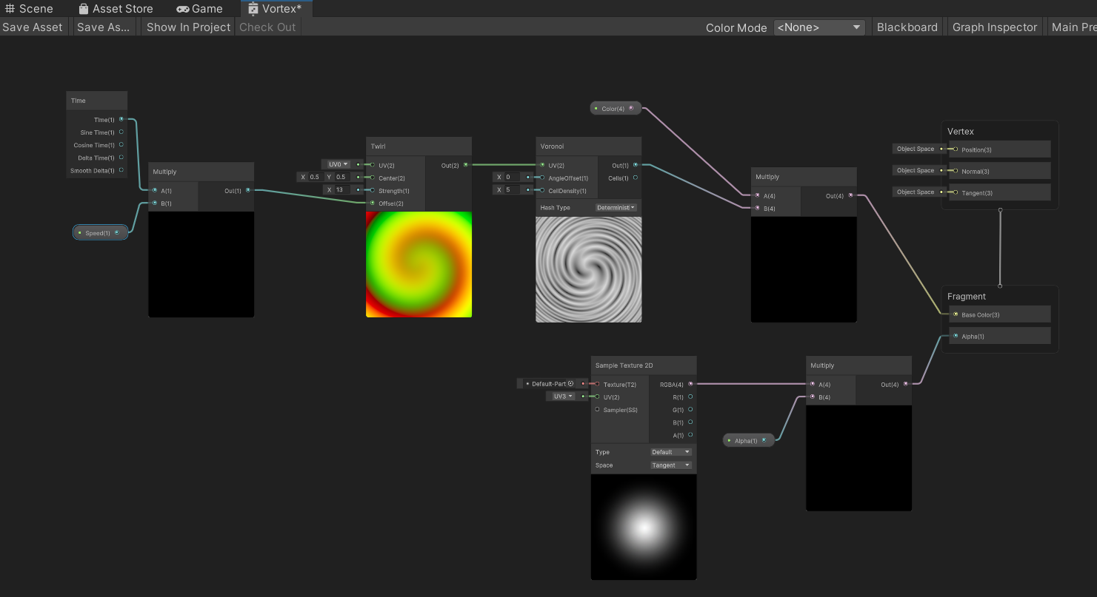

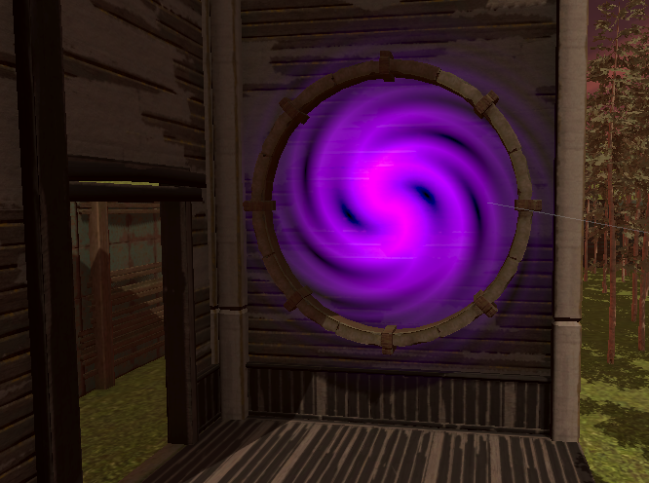

**Task-4**

Configure Lighting and Shadows

**Steps:**

* Go to Window -> Rendering -> Lighting and click on Generate Lighting to bake a light map.
* The lighting data will be stored in Assets -> Scenes -> [Scene Name]
* Go to the Inspector window of Directional Lighting and tweak the lighting and shadow related settings as per requirement.
* Increase light intensity from 1 to 1.2 and decrease shadow strength from 1 to 0.8
* The skybox selected also plays a part in the ambient lighting.

**Screenshots:  
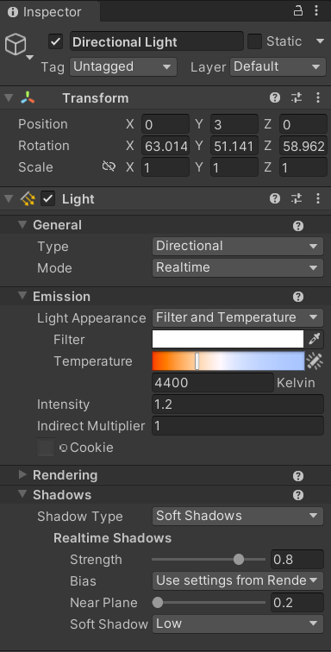**

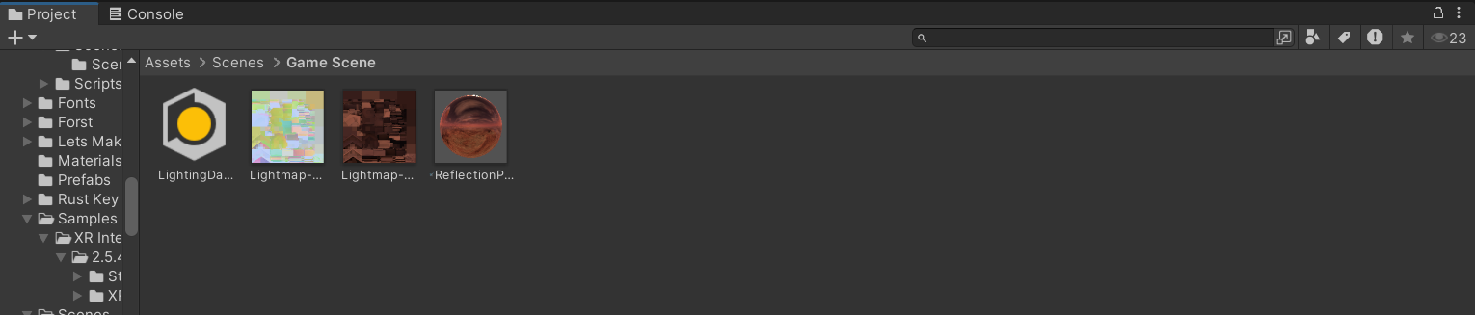

**Task-5**

Add Audio

**Steps:**

* Create an empty gameobject and name it “Background Music”
* Attach an AudioSource component to it.
* Import your background music in the Assets and then drag and drop it into the AudioClip variable.
* Select the boxes corresponding to “Loop” and “Play on Awake”

**Screenshots:**

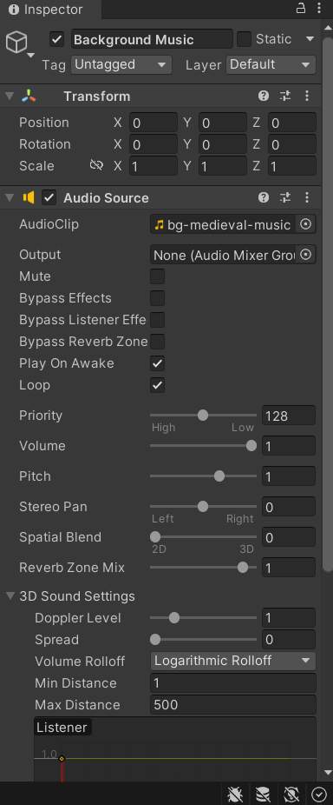

**Task-6**

Implement basic VR Interaction

**Steps:**

* Remove the XR Ray Interactor components from the Left Controller and Right Controller and add the downloaded hand model prefab as a child of the controller game objects.
* From Assets/Samples/XR Interaction Toolkit/2.5.4/Starter Assets/Prefabs/Interactors, drag and drop the Direct Interactor prefab as a child of Left and Right Controllers.
* Add a “Grabbable” tag to the props that you want to be able to grab.
* To all the props tagged as “Grabbable”, attach appropriate colliders, rigidbody and XR Grab Interactable components.

**Screenshots:**

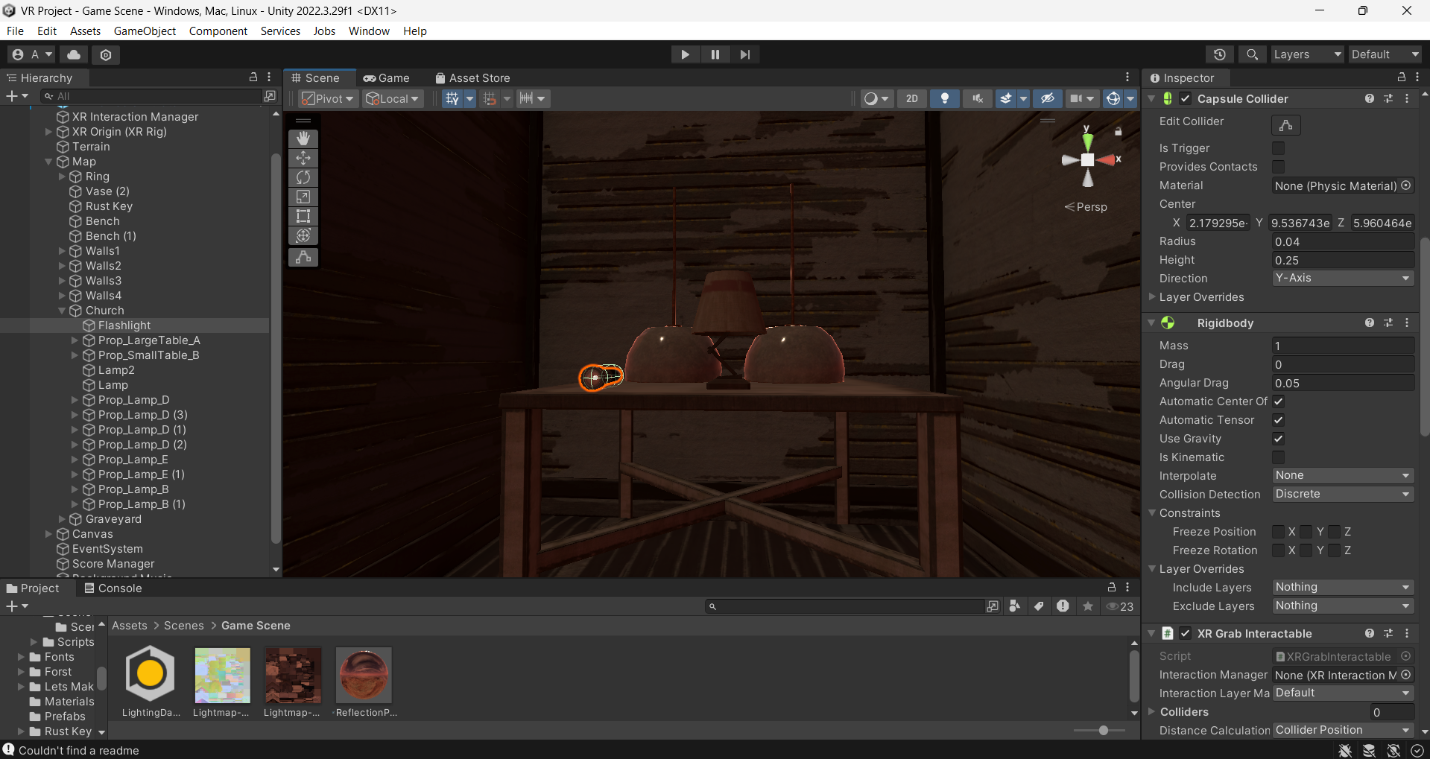

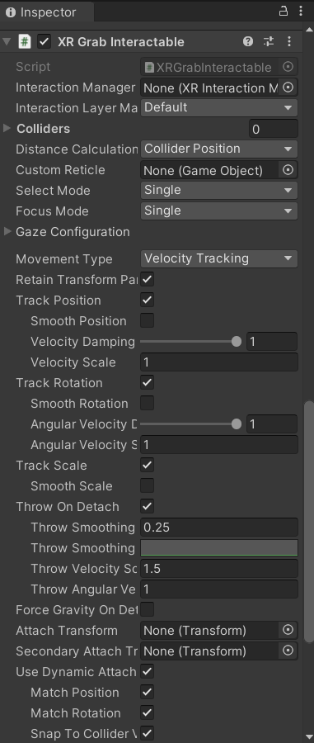

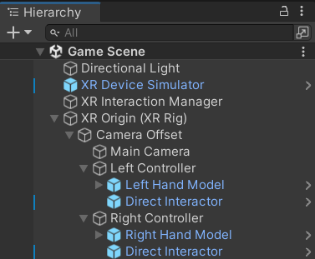

**Task-7**

Write the VR Interaction script

**Steps:**

* In the XR Grab Interactable component, set Movement Type to Velocity Tracking to prevent grabbed objects to pass through walls and tables.
* Also enable the Use Dynamic Attach checkbox.

**Screenshots:**



* XRGrabInteractable.cs =>

You can manually change the values of Movement Type and Use Dynamic Attach from the script as well

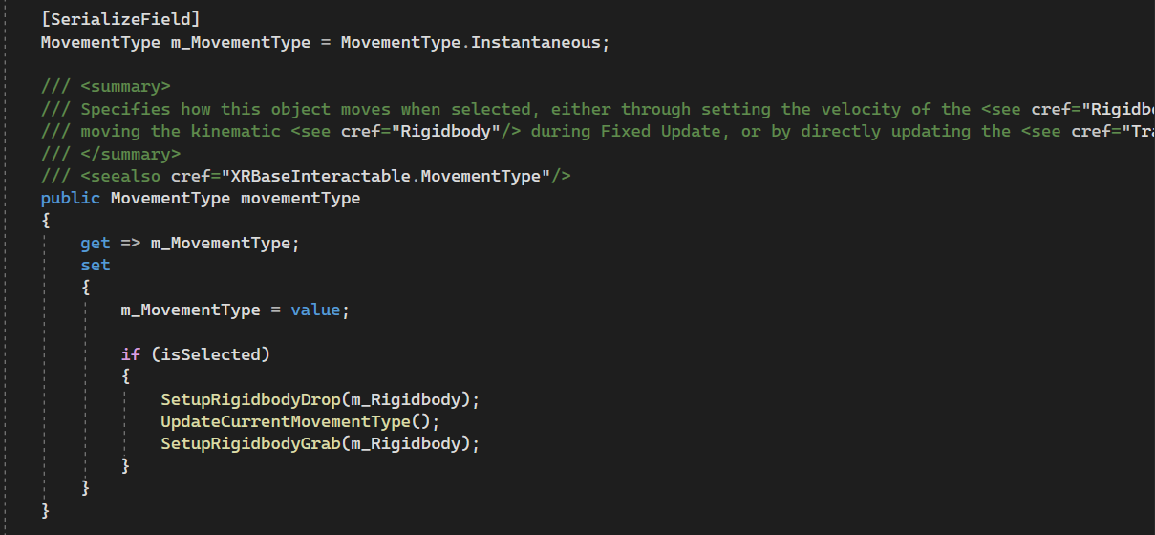

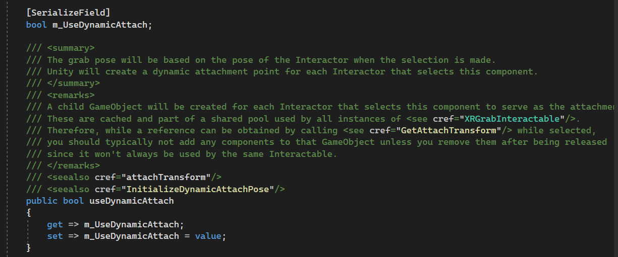

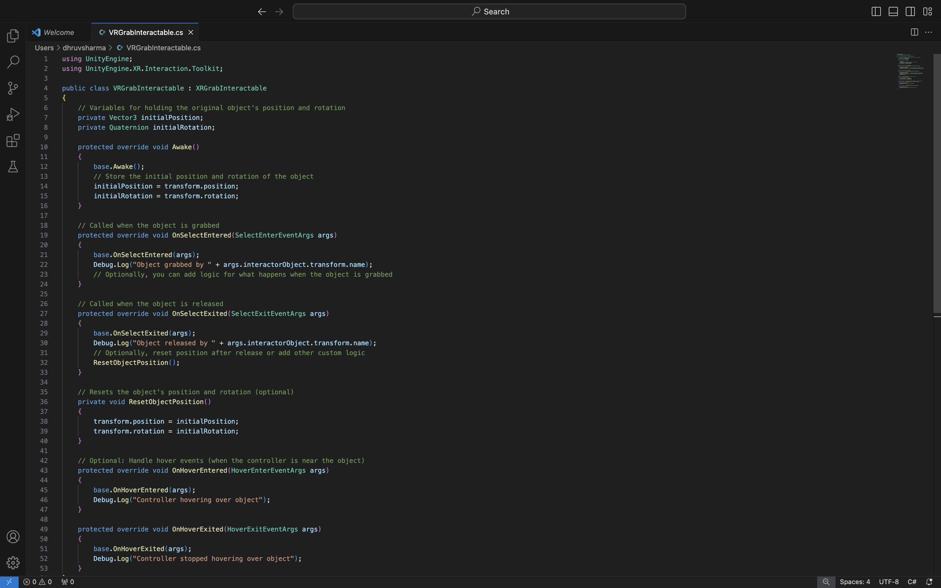

**Task-8**

Create a scoring mechanism

**Steps:**

* Create a gameobject named “Trigger Collider” as a child of the Ring gameobject. Attach a box collider to it, check the “Is Trigger” checkbox and add the TriggerHandler.cs script to it.
* Create an empty gameobject named “Score Manager” and attach the ScoreManager.cs script.
* Create an empty gameobject named “Game Manager” and attach the GameManager.cs script.
* Create a Canvas and add Text (TextMeshPro) gameobject as a child which will display the score.
* TriggerHandler.cs =>

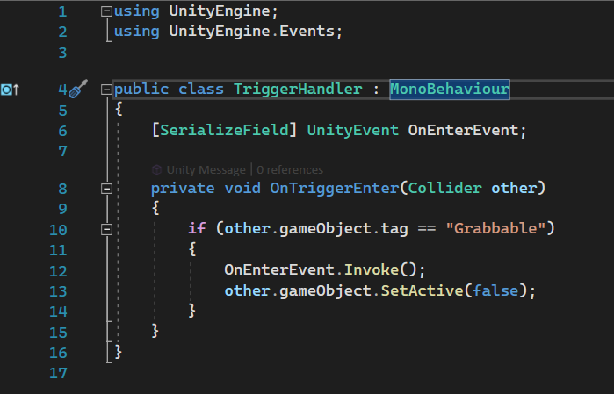

* ScoreManager.cs =>

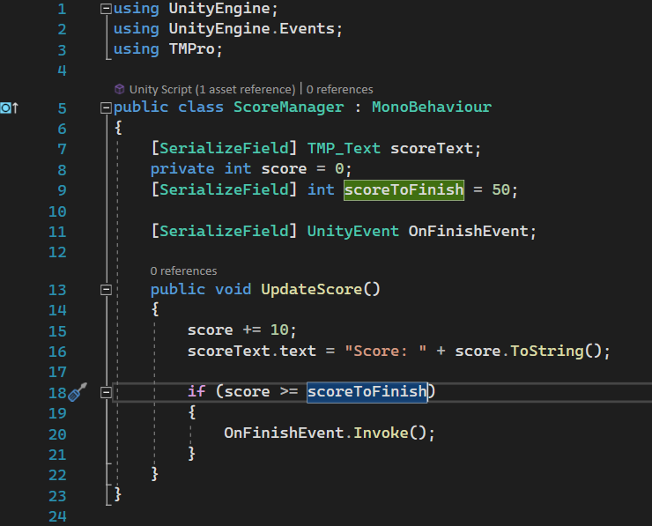

* GameManager.cs =>

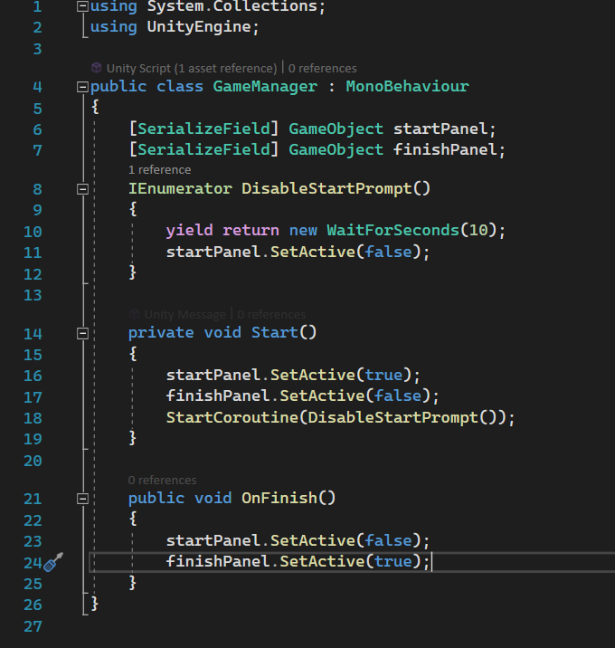

**Screenshots:**

